**MID TERM ONE ASSESSMENTS 2024**

**LEARNING AREA: LITERACY TWO**

**CLASS : PRIMARY TWO**

**PUPIL’S NAME :**

**Each correct answer carries two marks.**

**1.** Write one word for each given sound.

ir _____________ st ____________

br _____________ or ____________

2. Fill in the missing sounds.

t ___ ____ th Ea ___ t f ___ ____ d

s ___ n W ___ st

3. Write these words correctly.

lyfami ________________

ntau ________________

dengar ________________

byba ________________

4. Circle the words for the given sound.

oi: pail soil nail

ee: dream snail seed

ow: snow drum doctor

oo: bed book desk

5. Read and draw

|  |  |  |  |
| --- | --- | --- | --- |
| bottle | table | pineapple | triangle |
|  |  |  |  |

**6.** Write as one word

house + fly = ________________________

bed + bag = _________________________

pig + let = __________________________

pea + cock = ________________________

tea + pot = ________________________

**7.** write the first sound for these pictures.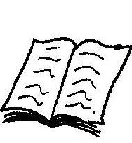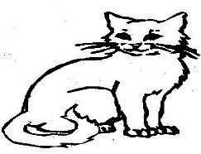

**8.** Make (**5)** correct sentences from the table.

|  |  |  |
| --- | --- | --- |
| I  We  They  He  It | am  are  is | crossing the road  eating food  playing football  driving a lorry  raining |

a _________________________________________

b _________________________________________

c _________________________________________

d _________________________________________

e _________________________________________

**9.** Read the poem and answer questions that follow in full sentences.

***Road Roads***

*Where buses, lorries, cars and bicycles pass, people walking on foot also use them,*

*For transporting goods,*

*like firewood, furniture, food and others*

*We use roads, let us keep them*

*in good conditions without potholes,*

*Because they are very useful.*

**By Joy**

**P.3**

**Questions**

a) What is the poem about?

____________________________________________________

b) Write any two means of transport in the poem.

i) __________________________ (ii) ________________________

c) Mention one thing that road transport.

______________________________________________________

d) Who wrote the poem?

_________________________________________________________

**SECTION B**

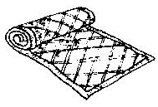**10.** Name pictures for sound ‘**m’ (6 marks)**

______________________

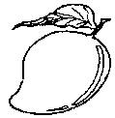

______________________

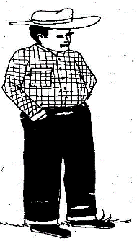

**______________________**

**11.** Colour this picture. (4marks)

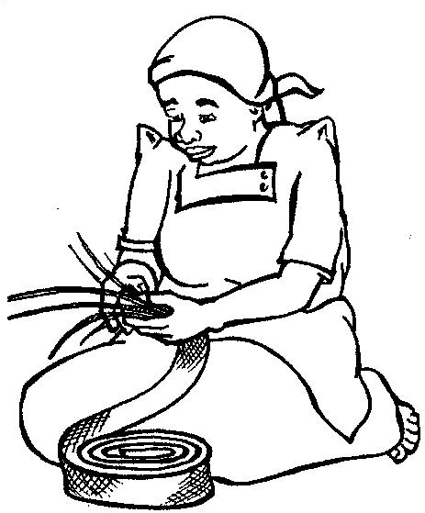

**12.** Copy the same. (10marks)



________________________________________________________________________________________________________________________________________________________________________________________________________________________________________________________________________



________________________________________________________________________________________________________________________________________________________________________________________________________________________________________________________________________



________________________________________________________________________________________________________________________________________________________________________________________________________________________________________________________________________



________________________________________________________________________________________________________________________________________________________________________________________________________________________________________________________________________